Press release
Obernai, 7th January 2020

Hager Group starts new Business Unit Hager Energy
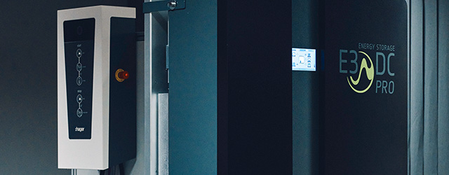

Ambition to play a leading role in renewable energy supply and management: With the beginning of the new year Hager Group starts the Business Unit Hager Energy.

“Our ambition is to play a leading role in the field of renewable energy supply and management” says CEO of Hager Group, Daniel Hager, “…based on our broad energy management offer such as Electrical Vehicle Charging Stations (EVCS), energy storage and energy management controlling, we offer our customers a complete and reliable system that reconciles energy consumption and environmental protection. We follow with it our vision of shaping tomorrow’s electrical world.”

The new business unit operates under the name Hager Energy and will address specific market segments in Europe relying on the two strong, complementary brands E3/DC - a subsidiary of Hager Group - and Hager. The new business unit, Hager Energy, is under the leadership of Andreas Piepenbrink, CEO and Rémy Becher, COO. Hager Energy will regroup team members who are already working on energy management projects. “We foster agility by bringing together E3/DC and Hager Group teams with common objectives and priorities. This is crucial to lead in this very promising and dynamic market,” comments Andreas Piepenbrink.

The highly innovative E3/DC applications complement the energy management offer of Hager Group. With E3/DC energy storage systems, users become more independent from the electricity grid, thus increasing the reliability of their supply and cost visibility. Self-generated electricity, such as energy from photovoltaic installations, can be stored depending on supply and demand. Hager Group is market leader in Europe in the development and production of central elements required for energy management, such as distribution boards, electric vehicle charging stations and control devices and associated software. The pooling of core competences creates a business unit that will offer existing and new customers highly innovative integrated solutions and services.

About Hager Group:
The Hager Group is a leading provider of solutions and services for electrical installations in residential, industrial and commercial buildings. Our services range from energy distribution and cable management to security systems and smart building automation. We are an independent, family-run business with headquarters in Blieskastel, Germany, and one of the leading innovators in our sector. Our 11,500 employees generate a turnover of around €2.19 billion. Customers in more than 120 countries rely on our components and solutions, which we produce in 23 locations around the world.

E3/DC
Founded in Osnabrück in 2010, E3/DC GmbH is the German market leader for emergency powered grid-connected energy storages using local solar power supply. Its three-phase energy storage and charging systems for electric vehicles provide the ultimate in self-sufficiency and savings for private and commercial buildings, particularly in the high-power range. E3/DC was acquired by Hager Group in 2017.

Contact

Michael Schattenmann
Group Communications
T +4968429452423
michael.schattenmann@hagergroup.com
hagergroup.com

